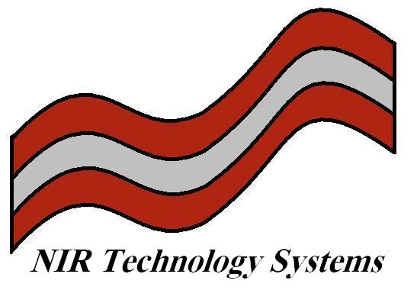

Technical Note 13: Calibration of NIR Instruments

Introduction

NIR spectroscopy is a secondary or correlative technique i.e. the spectral data collected is correlated through statistical means to some reference (laboratory) data. Regression techniques are used in order to develop a model, which is subsequently downloaded into an NIR analyser for use as a prediction tool.

The following steps, also presented in the following flow chart, outline the general steps in developing a calibration:

- Optimise sampling method.
    - Pathlength considerations (Cropscan 2-4abs, NIT 0-2abs)
    - Homogenisation procedures (FOP and NIT)
    - Reproducibility of chosen sampling technique

- Sample collection
    - Successful calibrations usually contain around 100 or more samples.
    - Should contain most of the variability expected for “real” samples.
    - Constituent concentrations ideally should be evenly distributed (box car distribution).

- Reference Analyses
    - Should be performed using accepted reference method.
    - Should be performed in duplicate (for error estimation in final method).
    - Should not differ by more than 5% (if so, repeat).

- Spectral Data
    - Samples should be run in duplicate.
    - Store spectral data along with reference data (Excel).

- Regression Analysis
    - Use chemometrics software package to perform:
      - Partial Least Squares (PLS) Analysis (Multiple Wavelengths).
      - Multiple Linear Regression (MLR) (Discrete Wavelengths).

- Download the Model
    - Validate the model on “real” samples.
    - Evaluate temperature stability.
    - Evaluate parameters such as repeatability and reproducibility.

Flow Chart for Calibration Development

Optimise Pathlength

Ensure Reproducible Spectra

Select Samples
(Box Car Distribution)

Analyse Samples
In Duplicate

Scan Samples
In Duplicate

PLS or MLR Calibration

Evaluate Calibration Models

Add 5 Low Temp and
5 High Temp Scans

Download Calibration
To Analyser

Test Temperature Stability and Repeatability

Calibration Techniques

Traditional Method for UV-Vis: Simple Linear Regression (SLR) sometimes known as Univariate Regression.

NIR Region: Usually requires some form of baseline correction, as a result of skew (caused by scatter or poorly resolved or overlapping peaks). As such, Multiple Linear Regression (MLR) techniques were developed to correct for these anomalies.

SLR follows the form of a straight line:

$$\%Y=b_{1}x+b_{0}$$

Where: Y is the constituent of interest
X is the absorbance at a specific wavelength
b₁ is the Calibration Factor or Slope or Coefficient
b₀ is the Intercept or Offset

Multiple linear Regression (MLR)

Used most commonly in UV-Vis and NIR to monitor absorbance or reflection at several wavelengths (filters) and relate these individual measures to the concentration of some analyte.

The model has the following general form. y=b₀+b₁x₁+b₂x₂
Where: b₀=y-intercept
b₁ and b₂=partial regression coefficients

Used in the case where the determination of one component is being interfered with by another. A simple two-component example serves as an example.
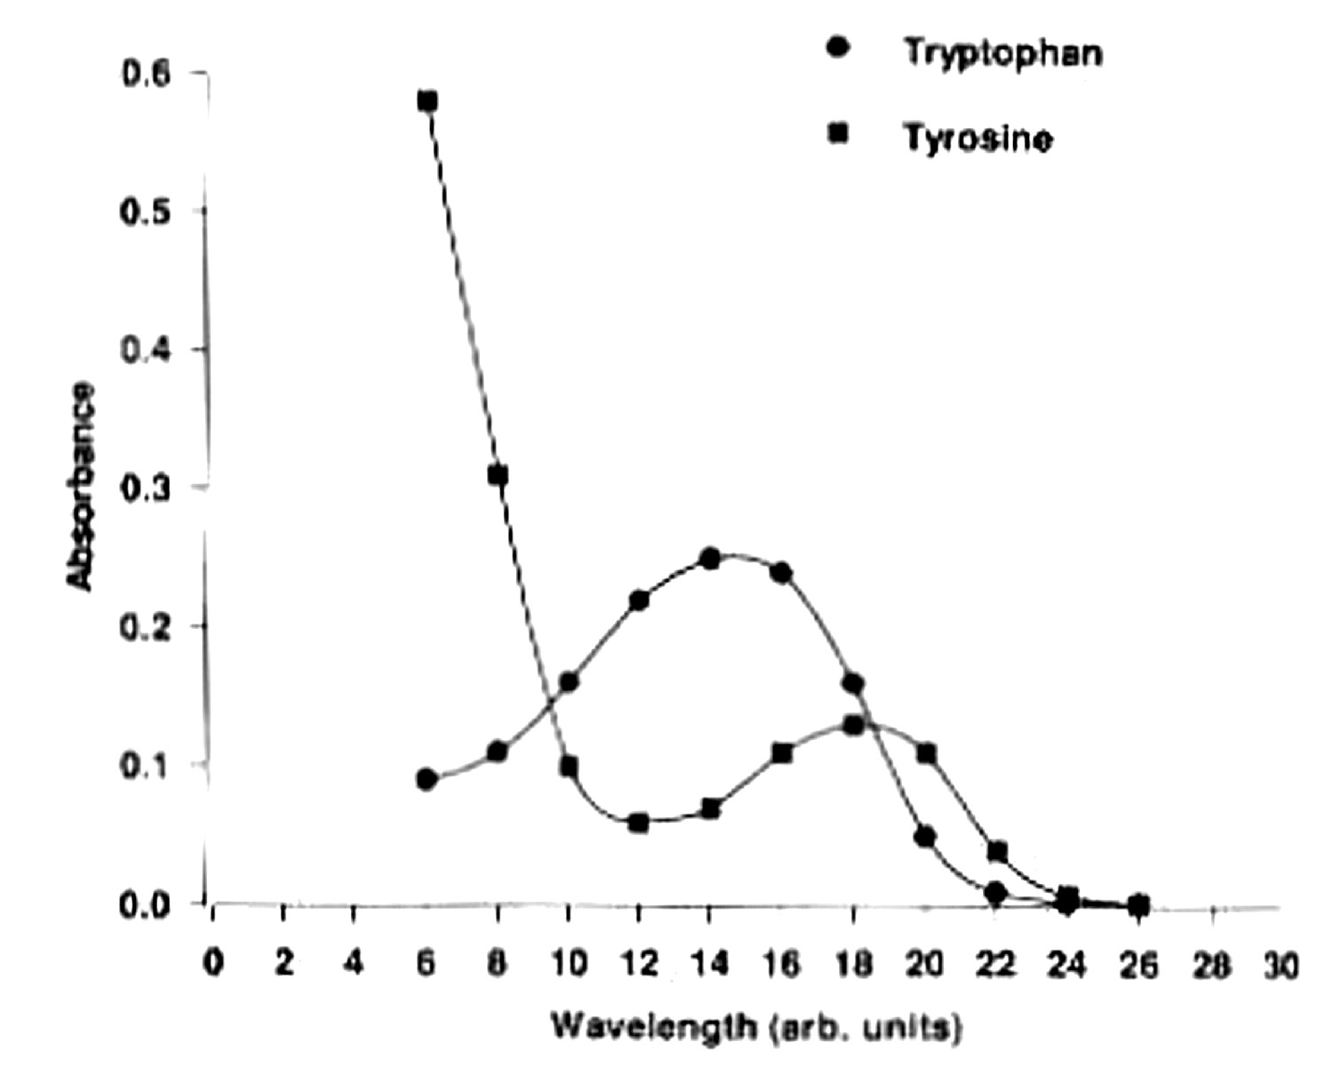

Univariate calibration using one wavelength ₁₄ shows a high correlation to tryptophan concentration, but the predictive ability is poor.

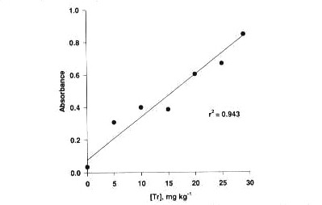

Model [C]=-2.00+38.51A₁₄

Actual | 7 | 14 | 27
Predicted | 10.26 | 11.14 | 28.20

Addition of a second wavelength to the model, based on visual inspection of the spectral data, shows that ₂₁ is relatively free from the absorption of tryptophan and contains more information on tyrosine.

Model [C]=-0.00067+43.68A₁₄+39.78A₂₁

A₂₁ compensates for the absorbance due to tyrosine.

Actual | 7 | 14 | 27
Predicted | 7.03 | 14.04 | 26.99

There are two methods for performing MLR

Stepwise Forward

Stepwise Backward

Stepwise Forward

- Select the first wavelength with the highest correlation.
- Regression looks for next wavelength, which will increase the correlation and reduce the error.
- Process is continued until the addition of the next wavelength has no effect or starts to reduce the correlation and increase the error.
- Best results from derivative spectra (removes baseline effects and spectral data are not intercorrelated).
- This technique, when used with derivative spectra, usually only requires two or three terms in the calibration equation. This reduces the tendency to overfit the data and results in more reliable predictions. (Note, in order to use derivative spectra, a full scanning spectrophotometer is required).

Stepwise Backward

- Takes all wavelength data until error increases and correlation drops.

- Used in original filter based instruments (Technicon, Dickey-John Perten).

- Can easily overfit data set resulting in poor prediction and poor reproducibility.

Partial Least Squares (PLS) Calibrations

PLS has become the preferred calibration technique as they allow the development of models for constituents, which cannot be modelled by MLR. PLS models also average the spectra and improve the signal to noise ratio.

PLS is defined as a global technique, i.e. the entire spectrum is used to develop a calibration and not just some highly correlated wavelengths. An example of a PLS regression profile is shown below.
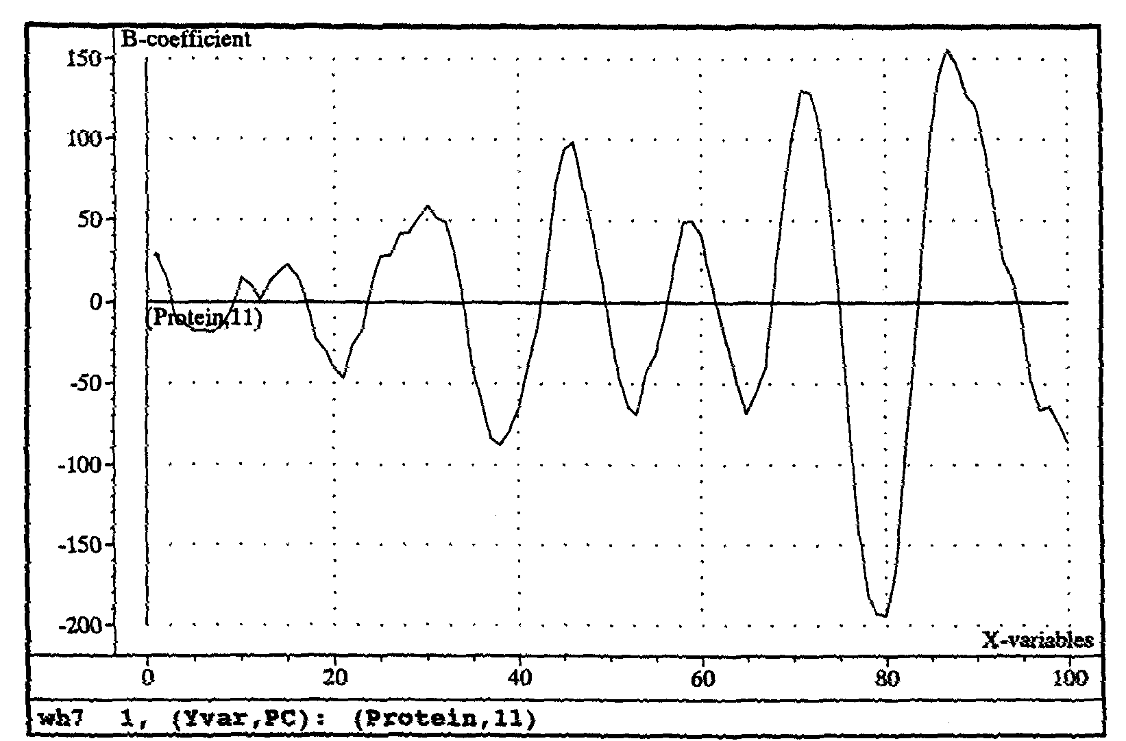
The plot represents the weightings or loadings, which are placed on each part of the spectrum. By adding the weighted wavelength readings and adding the regression offset b₀, a value of the constituent is obtained using the following equation:

$$\%Y=b_{0}+b_{1}λ_{1}+b_{2}λ_{2}+\text{.}\text{.}\text{.}\text{.}\text{.}\text{.}\text{.}\text{.}\text{.}\text{.}+b_{\text{38}}λ_{\text{38}}$$

Principal Components Regression

PLS is a form of Principal Components Regression (PCR). In PCR and PLS, the objective is to isolate Principal Components (PC’s) (or vectors of maximum variation) of the spectral data and then use these as terms in a calibration equation. Rather than using a single wavelength to characterise a peak, PLS and PCR estimate the shape of the peak or factors affecting the spectra and use these as x terms (spectral reconstruction).

PLS differs from PCR in that the constituent data is used in the computation of the PC’s. Generally PLS is used in preference to PCR in NIR spectroscopy, as PCR tends to incorporate too much redundant information.

Artificial Neural Networks (ANN)

ANN has been used extensively in NIR spectroscopy as an alternative to PLS and MLR. ANN is not a calibration model, but relies on a training algorithm based on a large data set. Computations are based more on discriminant-based functions looking more for spectral similarity to those in the database.

ANN techniques have the advantage that they can handle non-linearity between the spectral data and the constituents and offer multiple opportunities for optimisation whereas a PLS or MLR calibration has only one option. An ANN technique can fit the unknown spectra to a large number of like spectra. A PLS or MLR calibration can only multiple the spectra by the b-coefficients add them and then add the offset to produce the constituent data. If the spectrum is not similar to that of the calibration set, then PLS and MLR models will produce the wrong result.

Below is a schematic of a Decision Making Tree that demonstrates the concept of ANN, however the Foss ANN does not work exactly like this schematic.

Unknown Spectrum
Node 1
Node 2
Node 3
Node 5
Spectra Matches
Predicts
Protein = 12.2%
Moisture = 12.4%
Node 4

Discriminant Analysis

Discriminant Analysis is a qualitative tool used to group (or classify) spectra into pre-defined classes. The first step of the process is to perform a Principal Components Analysis (PCA) and plot the most significant PC’s in order to identify any clustering of spectra (known as Cluster Analysis).

Cluster Analysis is commonly called an unsupervised analysis, as the number of clusters is not known and must be determined by visual inspection of the data. Clusters are usually found using two methods:

- Correlation techniques- Samples are grouped based on how they correlate to each other.

- Distance measures- Samples are grouped based on how close they are to each other.

One distance of measure is known as the Mahalanobis distance, and is commonly used in statistical methods to define closeness of objects. The Mahalanobis Distance can be visualised in the following diagram. Each wavelength reading, ie. absorbance value in the spectrum, is considered an independent axis with a value equivalent to the absorbance value. The diagram only shows three axes, however in NIR the number of vectors is generally hundreds. The resultant vector, ie, the sum of the three vectors produces a unique vector that represents the entire spectrum.

Axis 1 (Abs 1)

Resultant Vector

Axis 3 (Abs 3)

Axis 2 (Abs 2)

Spectra that are similar will have a Resultant Vector with the same angle and length. Normally spectra of even the same sample vary due to packing density, particle size and purity. As such the resultant vectors of spectra from many sample sof the same material form an ellipse in space. This is the Cluster that defines the variation in spectra of the specific material. By building a library of spectra for each material, Discriminant Analysis can be used to identify unknown spectra against the library. The closer the resultant vector of the unknown sample is to the Cluster, then the better the fit. The Mahalanobis Distance is the parameter that is calculated to determine how close the unknown spectrum is to each Cluster in the library. If the Mahalanobis Distance is “0”, then the spectrum matches perfectly. As such, the smallest Mahalanobis Distance is used to pick which Cluster the unknown spectrum fits best.

Discrimination Analysis is used for two tasks:
- Identification of Unknown Materials
    - Requires library of known materials
    - Matches unknown material to a class defined by the training set
    - Displays top five matches along with the statistical relevance

- Quantification of Materials or Sameness

Comparison of known material to a library sample to measure sameness. The concept of Sameness may be a strange term, but the idea is simple. If a manufacturer buys 10 tonnes of a chemical additive, they want to know if it is the same as the last batch or at least as same as the batches which have proven to be acceptable.

Since the NIR spectrum of a material contains information about the chemical composition, as well as the physical characteristics, eg. Particle size and size distribution, compaction, crystallinity etc, then Discriminant Analysis provides a means of inspecting the whole material rather than making a QC assessment on just a couple of chemical tests.
NIR Technology Systems
366 Edgar Street, Condell Park, NSW, 2200, Australia
Tel: 612 9708 5068, Fax: 612 9708 5537
Email: nirtech@nirtech.net, Web: www.nirtech.net

